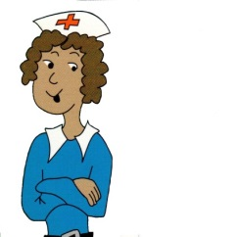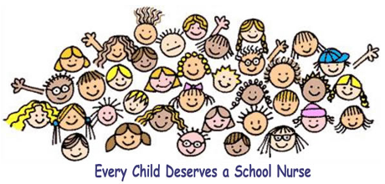

**A self-help guide**

Primary School

**Parents/Carers**

It’s important to share with your parents / carers how you are feelings so that they can help you.

**Child Line**

It won’t cost you any money to call this telephone number and you can talk about **anything** that is worrying you.

**0800 1111 – open 24hrs a day**



**School Teacher/Staff**

You can talk to any member of school staff about how you are feeling.



**Information for Parents/Carers -**

**How to contact your School Nurse**

School Nurses are available between:

9.00am – 5.00pm

Monday – Friday throughout the year, including school holidays.

Every school has a named School Nurse. Please speak to the school reception for details of your School Nurse.

Alternatively you can contact the Dudley School Nursing Admin Team on:

**Tel: 01384 408990**

**The School Nurse**

Ask at the reception office in your school to see to your School Nurse.

**Help Lines / Contacts**



**Health**

**Emotional**



**First Aid Kit**

Shropshire Community Health NHS Trust

**www.shropscommunityhealth.nhs.uk**

Trust Headquarters: William Farr House, Mytton Oak Road, Shrewsbury, Shropshire, SY3 8XL, Tel: 01743 277500

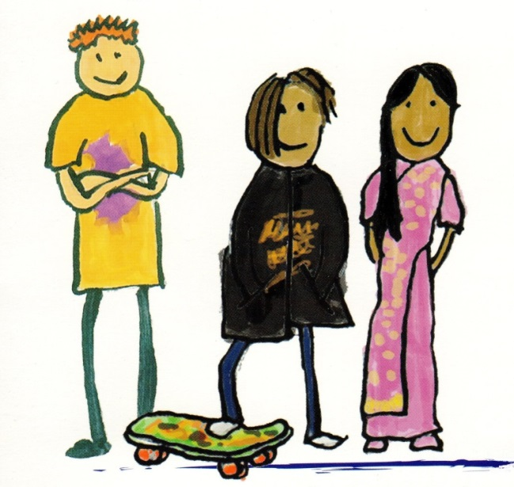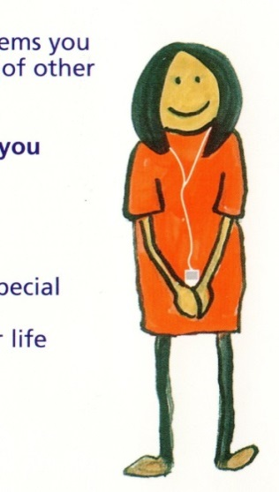

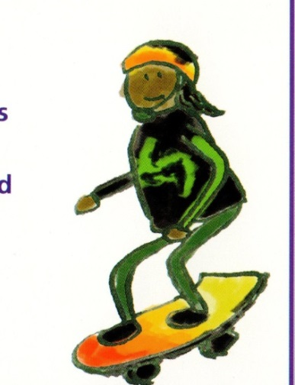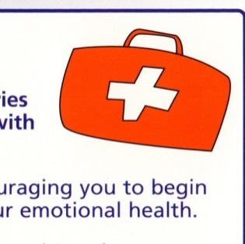

**Positive steps to improving emotional health**

* **Make time to do things you enjoy**
* **Talk to friends and loved ones**
* **Get plenty of sleep**
* **Take regular exercise**
* **Eat a healthy diet**
* **Drink plenty of water**
* **Find time to relax**
* **Do not be afraid to ask for help**
* **Be kind to yourself and others**
* **If something is bothering or making you feel sad, worried or upset, always ask for help**
* **Share your feelings**



Making this First Aid Kit is a way of helping you to begin to think about how you can look after your thoughts and feelings.

It helps you to make your own decisions about how you look after yourself.

The Emotional Health First Aid Kit is a collection of items that will help you to relax and feel more positive. You may want to take it with you if you know you are going to be in a difficult situation.

This ‘First Aid Kit’ is just for you, so you can decide what goes in it.

**Making your First Aid Kit**

Choose a container to hold your ‘items’. It could be a box, a bag or an envelope, anything you like. You could decorate and customise it.

We have given you some ideas of what you might want to put in your First Aid Kit to get you started. If you can think of other items that help you, add those too.

**In your Emotional Health First Aid Kit you could have:-**

* **A list of your favourite happy songs so that you can listen to them when you feel sad or worried**
* **Photographs or pictures** **of someone or something that makes you feel happy**
* It could be a TV programme
* A picture of you on holiday
* A place you might like to visit
* **People you can talk to**
* Someone who works at your school
* the School Nurse
* Child Line
* **Words from your favourite book, a film or a positive quote**
* **Something that you are proud of**
* a certificate
* a list of things that you like about yourself
* **A piece of paper with positive comments others have made about you.**

You could ask your parents / carers / family or friends to write some down for you.

**We all have emotional health needs at different times in our lives.**

**Sometimes we may feel sad, upset, worried or feel stressed and at other times we may feel happy and that we can achieve anything.**